LORETO GIRLS 2025 PREDICTION
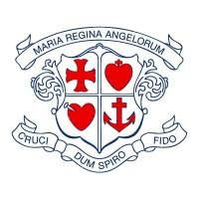

(EXPECTED KCSE EXAM)
Kenya Certificate of Secondary Education (K.C.S.E)
CHEMISTRY
PAPER 3
PRACTICAL
CONFIDENTIAL OF REQUIREMENTS

- Burette
- Pipette
- 2 conical flasks
- 120cm³ of 2.0M NaoH labelled B
- 100cm³ 0f 0.2M H₂SO₄ labelledA
- 250cm³ volumetric flask
- A label
- Pipette filter
- Stand and clamp
- 500cm³ distilled water
- Phenolphthalein indicator
- 100cm³ plastic beaker
- Thermometer
- 10cm³ measuring cylinder
- 100cm³ measuring cylinder
- 50cm³ 2.0M HCl , Solution D
- 50cm³ 2.0M NaoH
- 6 test tubes in a test tube rack
- 0.2g of solid N (Al₂(SO₄)₃]

REAGENTS
- 2M NaoH
- 2M NH₄OH
- Ba (NO₃) ₂solution
- 2M nitric acid
- Potassium iodide solution

